**Challenge Two**

**Description**

As a QA Engineer I want to run my automated tests on Jenkins every night because I want to see the results every morning.

**AcceptanceCriteria**

• When I install Jenkins I want a local Jenkins instance to run on my computer • I want to configure a Jenkins Job to run my automated tests on Jenkins, scheduled for noon everyday on one browser of my choice, including a generated Test report for your scenarios. • If possible host the Jenkins. If not please send an attached documentation regarding your setup.

**Steps to configure Jenkins job to run automated test, scheduled for noon everyday:**

1: Navigate to the Jenkins dashboard (<http://localhost:8080>) in the browser window.

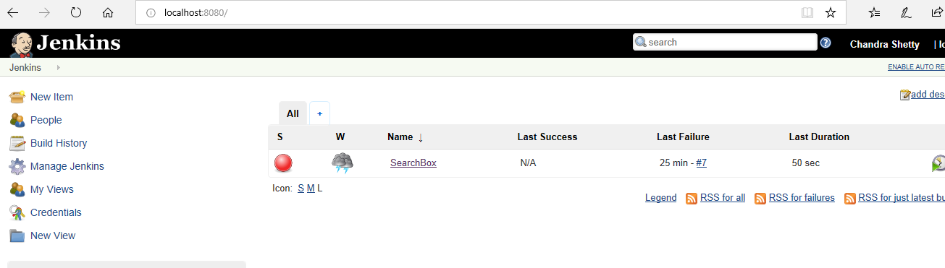

2. Click on the **New Item** link to create a jenkins job.

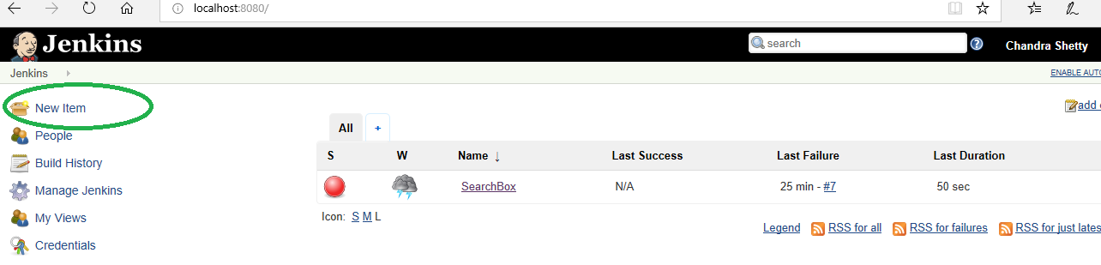

3. Select the FreeStyle project radio button as shown in the following screenshot:

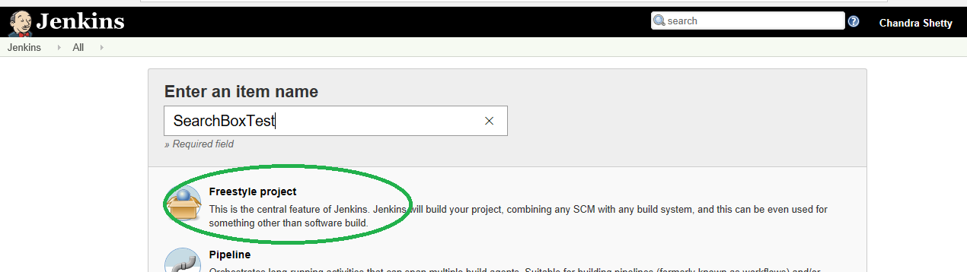

4. Click on OK button. A new job with name "SearchBoxTest" is created in Jenkins Dashboard.

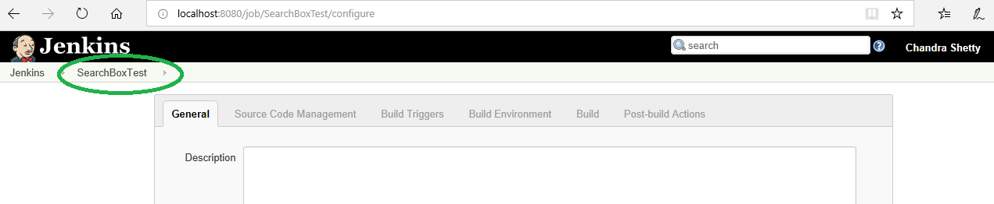

5. Configure JDK as shown in the screen shot below:

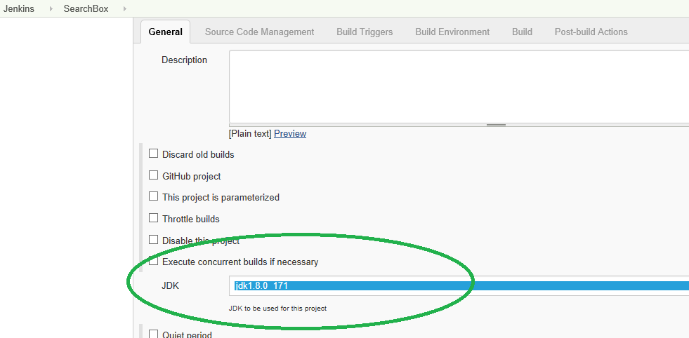

6. Set the Maven project path in use custom workspace

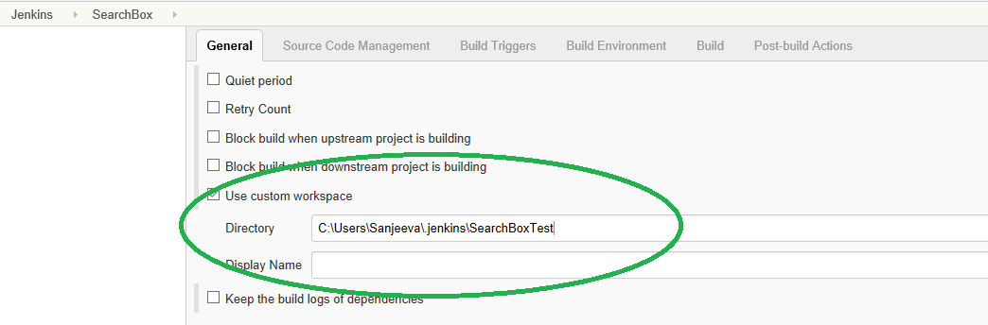

7. Scheduling Jenkins for automatic execution. Trigger build at 1PM everyday (cron expression-0 13 * * 1-7)as shown in screen shot below:

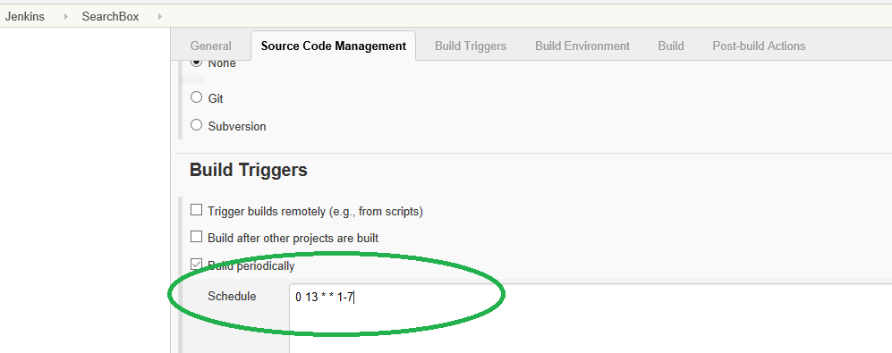

8. Set the goals as ‘test’ in Invoke top-level Maven targets as shown in screenshot below:

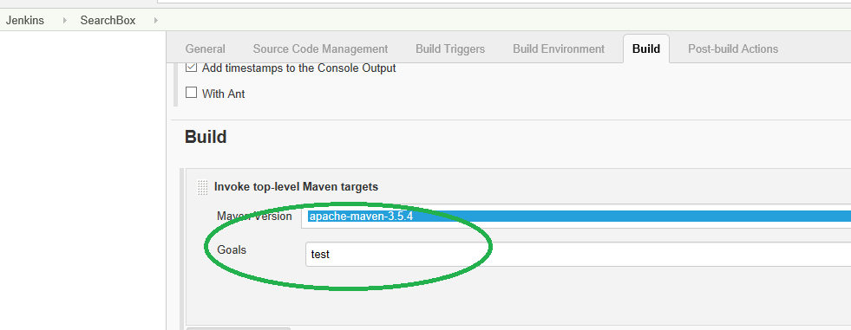

9. Save all the configuration, New job can be seen in Jenkins dashboard as shown in screenshot below:

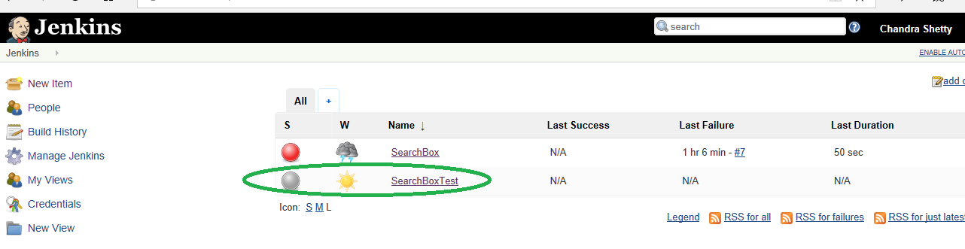

* Since the build is scheduled to trigger every afternoon at 1PM, can expect new build every day.